**PROJECT REPORT**

**On**

**COLLEGE-FINDER**

Submitted in partial fulfillment of the requirement for the

Course Lab Oriented Project (CSP4401) of

**COMPUTER SCIENCE AND ENGINEERING**

**B.E BATCH-2016**

**in**

**November-2019**

**12.png**

**Under The Guidance of: Submitted By:**

**Mr. MUKESH VASU**

**Ms. VAISHALI 1611981408**

**UTTKARSH SAHORE**

**1611981405**

**DEPARTMENT OF COMPUTER SCIENCE & ENGINEERING**

**CHITKARA UNIVERSITY**

**HIMACHAL PRADESH, INDIA**

**CERTIFICATE**

This is to be certified that the project entitled “**College-Finder**” has been submitted for the Bachelor of Computer Science Engineering at Chitkara University, Himachal Pradesh during the academic semester July 2019-December-2019 is a bonafide piece of project work carried out by **VASU 1611981408, UTTKARSH SAHORE 1611981405** towards the partial fulfillment for the award of the course Integrated Project (CSP-4401) under the guidance of **MR. MUKESH and MS. VAISHALI.**

**Signature of Project Guide**

Mr. MUKESH

Ms. VAISHALI

(Assistant Professor CSE)

**CANDIDATE’S DECLARATION**

We, **VASU 1611981408 UTTKARSH SAHORE 1611981405** , B.E.-2016 of the Chitkara University, Himachal Pradesh hereby declare that the Integrated Project Report entitled “**College-Finder**” is an original work and data provided in the study is authentic to the best of our knowledge. This report has not been submitted to any other Institute for the award of any other course.

**VASU UTTKARSH SAHORE**

**1611981408 1611981405**

**Place:**

**Date:**

**ACKNOWLEDGMENT**

It is our pleasure to be indebted to various people, who directly or indirectly contributed in the development of this work and who influenced our thinking, behavior and acts during the course of study.

We express our sincere gratitude to all for providing an opportunity to undergo Integtrated Project as the part of the curriculum. We are thankful toMR. MUKESH and MS. VAISHALI

for her support, cooperation, and motivation provided to us during the training for constant inspiration, presence and blessings.

We also extend our sincere appreciation toMR. MUKESH and MS. VAISHALI who provided his/her valuable suggestions and precious time in accomplishing our Interated project report.

Lastly, we would like to thank the almighty and our parents for their moral support and friends with whom we shared our day-to day experience and received many suggestions that improve our quality of work.

**VASU UTTKARSH SAHORE**

**1611981408 1611981405**

**TABLE OF CONTENTS**

|  |  |
| --- | --- |
| **List** | **Page No.** |
| 1. Abstract | 1 |
| 1.1 Keywords | 2 |
| 2. Introduction | 3 |
| 2.1 Background | 3 |
| 2.2 Problem Statement | 4 |
| 3 Software and Hardware Requirement | 5 |
| 3.1 Methods | 5 |
| 3.2 Programming Working Environment | 6 |
| 3.2.1 HTML | 6 |
| 3.2.2 EJS | 7 |
| 3.2.3 CSS | 8 |
| 3.2.4 JavaScript | 9 |
| 3.2.5 Jquery | 11 |
| 3.2.6 Bootstrap | 12 |
| 3.3 Requirement to run application | 13 |
| 4. Database,Design and implementation | 15 |
| 5. Program Structure and GUI construction | 16 |
| 6. Code implemenation and Database Connection | 20 |
| 6.1 Code Details and implementation | 20 |
| 6.1.1 MongoDB and Compass | 20 |
| 6.2 Database Connection | 22 |
| 7. Limitations | 23 |
| 8. Conclusion | 24 |
| 9. Future Scope | 25 |
| 10. Bibliography | 26 |

**LIST OF FIGURES**

|  |  |
| --- | --- |
| **Figures** | **Page No.** |
| Fig 3.1 HTML-5 | 6 |
| Fig 3.2 Declaration of HTML-5 | 7 |
| Fig 3.3 CSS-3 | 8 |
| Fig 3.4 Internal CSS | 9 |
| Fig 3.5 Inline CSS | 9 |
| Fig 3.6 External JavaScript File | 10 |
| Fig 3.7 Jquery Symbol | 11 |
| Fig 3.8 Jquery Code | 11 |
| Fig 3.9 Bootstrap 4 | 12 |
| Fig 3.10 Bootstrap and Container Class | 13 |
| Fig 4.1 Data Flow Diagram | 15 |
| Fig 4.2 MongoDB Compass | 15 |
| Fig 5.1 Initial Home Page | 16 |
| Fig 5.2 Add College Page | 16 |
| Fig 5.3 Reviews Form | 17 |
| Fig 5.4 Login Form | 18 |
| Fig 5.5 Full Screen Header | 19 |
| Fig 5.6 Admin Panel | 19 |
| Fig 5.7 User Panel | 19 |
| Fig 6.1 Database Connection | 21 |
| Fig 6.2 Compass Dashboard | 21 |
| Fig 6.3 Project Database | 22 |

**1. ABSTRACT**

As the student completed high school education and go for higher studies needs to get the unbaised reviews about colleges/universities. Parents who are seeking information on higher education sector in India provided with an unbaised reviews of colleges/universities across India. Develop a web application that fulfill the students with the knowledge so that they make wiser decision while choosing their carrer.

The project report starts with brief introduction of our project, its main aim, technologies used for making a working project. Introduction part consists of problem statement, brief of web application, what it can do, its specifications and how certain tasks will be performed followed by the introduction of languages used for front-end development of our project to make it look attractive. Every chapter of this project report will contain snapshots of working on the project to make it look more understandable. Languages used are HTML, CSS, JavaScript, Nodejs and jquery. For the responsiveness of a website, bootstrap 4 framework is used.

For the back-end, we have used Javascript for data-retrieval and sending purposes to/from database.

The next section contains our approach to the problem and how we solved it with the help of technologies like MongoDB database , languages mentioned above to make a web application.

Our final product will be a complete web application that will cover all the required aspects of the problem and will help the students in the best possible way.

**1.1: Keywords-**

* HTML(EJS)
* CSS
* JavaScript(Expressjs)
* Jquery
* Bootstrap
* Front-end
* Back-end
* MongoDB
* Nodejs
* Developer
* Web application
* Potential User
* Programming Platform

**2. INTRODUCTION**

**2.1: Background**

This project demands developing a web application which could be accessed through any device regardless of its size. In this web application, potential user will first have to sign up

by giving their necessary details like username, e-mail address and their password. Once the admin verifies the user then the user can post the reviews of the colleges/universities. If the user is not logged in or his/her session is already closed, he/she is not able to post any reviews about the colleges. User can edit his posts. All the reviews are checked by admin before posting on the portal.

The prerequisites of developing this kind of web application are:

* One should have basic knowledge of client/server architecture.
* He/she should have worked on languages like HTML, CSS and Javascript for front-end development.
* Knowledge of sending and retrieving data from database.
* One should also know how to install a server on their device.
* At least one server-side language must be known to the developer.

Before starting developing this project, a team is divided into 2/3 halves. One will develop the front-end or the client-side part and other will create and manage the server side for dynamic data so that data can transported from server to client and vice-versa.

For the front-end part, simple EJS (Embedded Javascript) will be used to display static data. Then most important thing that is layout of website will be designed. For this purpose we will use bootstrap 4 frameworks which is a EJS, CSS and JavaScript framework to make our web application responsive that is it will look good in all devices. It also provides with a grid system to make our website responsive. It also contains some predefined libraries of CSS, JavaScript to make designer’s work easier. Then header, body and footer of the user interface will be designed followed by a navbar throughout the web application.

Now for the back-end part, first a local host server will be installed on our computer. For this application we have used MongoDB and its GUI product Compass.

For including stylish icons and fonts in our web application , we will use font awesome by including file in our javascript pages.

**2.2 Problem Statement**

As the student completed high school education and go for higher studies needs to get the unbaised reviews about colleges/universities. Parents who are seeking information on higher education sector in India provided with an unbaised reviews of colleges/universities across India. Develop a web application that fulfill the students with the knowledge so that they make wiser decision while choosing their carrer.

**3.** **SOFTWARE AND HARDWARE REQUIREMENT SPECIFICATION**

**3.1 Methods**

**Options Available:**

**React JS:**

Angular modifies the DOM directly. This is faster.

**Node JS:**

It provides an opens source run time environment.

**Used:**

**Client Side:**

In this project we are using Html, CSS, JavaScript, Bootstrap to make the Frontend more agile.

**Server Side:**

We are using Javascript language, a server side scripting language to connect the database to the web server.

**3.2: Programming/working environment**

**3.2.1 HTML**

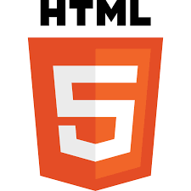

**Figure 3.1: HTML-5**

**Hypertext Markup Language** (**HTML**) is the standard markup language for creating web pages and web applications. With Cascading Style Sheets (CSS) and Javascript, it forms a triad of cornerstone technologies for the World Wide Web.

Web browsers receive HTML documents from a web server or from local storage and render the documents into multimedia web pages. HTML describes the structure of a web page semantically and originally included cues for the appearance of the document.

HTML elements are the building blocks of HTML pages. With HTML constructs, images and other objects such as forms may be embedded into the rendered page. HTML provides a means to create structured documents by denoting structural semantics for text such as headings, paragraphs, lists, links, quotes and other items. HTML elements are delineated by *tags*, written using angle brackets. Tags such as <**img** /> and <**input** /> directly introduce content into the page. Other tags such as <**p**>surround and provide information about document text and may include other tags as sub-elements. Browsers do not display the HTML tags, but use them to interpret the content of the page.

HTML can embed programs written in a scripting language such as JavaScript, which affects the behavior and content of web pages. Inclusion of CSS defines the look and layout of content. The World Wide Web Consortium (W3C), maintainer of both the HTML and the CSS standards, has encouraged the use of CSS over explicit presentational HTML since 1997.

We have used latest version of html that is html 5 which includes new features like <audio>, <video> and <canvas> tag. For writing code in html 5, we have to include <! doctype html>at the starting of any page as shown below.

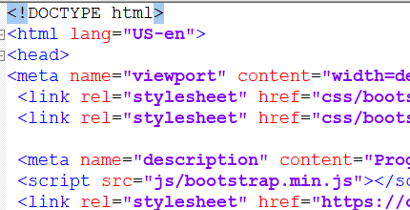

**Figure 3.2: Declaration of html 5**

**3.2.2 EJS(Embedded Javascript Elements)**

EJS is a templating language that lets you generate HTML markup with plain Javascript. No reinvention of iteration and control-flow. It provides fast rendering and compilation.

**3.2.3 CSS**



**Figure 3.3: CSS-3**

CSS is one of the core languages of the **open web** and is standardized across browsers according to the W3C specification. Developed in levels, CSS1 is now obsolete, CSS2.1 is a recommendation, and CSS3, now split into smaller modules, is progressing on the standardization track.

**Cascading Style Sheets** (**CSS**) is a style sheet language used for describing the presentation of a document written in a markup language like HTML.CSS is a cornerstone technology of the World Wide Web, alongside HTML and JavaScript.

CSS is designed to enable the separation of presentation and content, including layout, colors, and fonts.This separation can improve content accessibility, provide more flexibility and control in the specification of presentation characteristics, enable multiple web pages to share formatting by specifying the relevant CSS in a separate .css file, and reduce complexity and repetition in the structural content.

Separation of formatting and content also makes it feasible to present the same markup page in different styles for different rendering methods, such as on-screen, in print, by voice (via speech-based browser or screen reader), and on Braille-based tactile devices. CSS also has rules for alternate formatting if the content is accessed on a mobile device.

The name cascading comes from the specified priority scheme to determine which style rule applies if more than one rule matches a particular element. This cascading priority scheme is predictable.

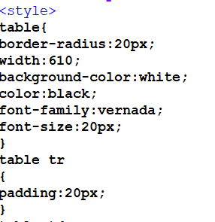

**Figure 3.4: Internal CSS**



**Figure 3.5: Inline CSS**

**3.2.4 JavaScript**

**JavaScript** often abbreviated as **JS**, is a high-level, interpreted programming language. It is a language which is also characterized as dynamic, weakly typed, prototype-based and multi-paradigm.

Alongside HTML and CSS, JavaScript is one of the three core technologies of the World Wide Web. JavaScript enables interactive web pages and thus is an essential part of web applications. The vast majority of websites use it, and all major web browsers have a dedicated JavaScript engine to execute it.

As a multi-paradigm language, JavaScript supports event-driven, functional, and imperative (including object-oriented and prototype-based) programming styles. It has an API for working with text, arrays, dates, regular expressions, and basic manipulation of the DOM, but the language itself does not include any I/O, such as networking, storage, or graphics facilities, relying for these upon the host environment in which it is embedded.

Initially only implemented [client-side](https://en.wikipedia.org/wiki/Client-side) in web browsers, JavaScript engines are now embedded in many other types of host software, including [server-side](https://en.wikipedia.org/wiki/Server-side) in web servers and databases, and in non-web programs such as word processors and PDF software, and in runtime environments that make JavaScript available for writing mobile and desktop applications, including desktop widgets.

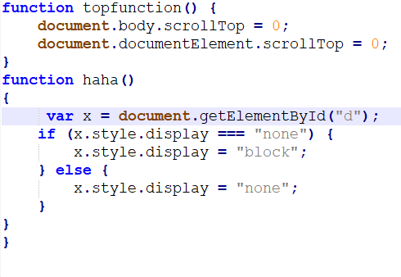

**Figure 3.6: External Javascript file**

**3.2.5 Jquery**



**Figure 3.7: Jquery Symbol**

**Jquery** is a cross-platform JavaScript library designed to simplify the client-side scripting of HTML. It is free, open-source software using the permissive MIT License.Web analysis indicates that it is the most widely deployed JavaScript library by a large margin.

jQuery's syntax is designed to make it easier to navigate a document, select [DOM](https://en.wikipedia.org/wiki/Document_Object_Model) elements, create animations, handle events, and develop Ajax applications. jquery also provides capabilities for developers to create plug-ins on top of the JavaScript library. This enables developers to create abstractions for low-level interaction and animation, advanced effects and high-level, theme able widgets. The modular approach to the jquery library allows the creation of powerful dynamic web pages and Web applications.

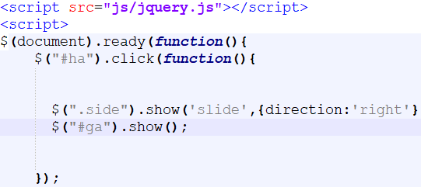

**Figure 3.8: Jquery Code**

**3.2.6 Bootstrap**

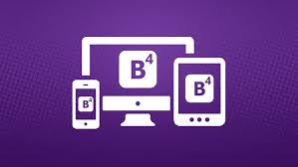

**Figure 3.9: Bootstrap-4**

Bootstrap is a free front-end framework for faster and easier web development. Bootstrap includes HTML and CSS based design templates for typography, forms, buttons, tables, navigation, modals, image carousels and many other, as well as optional JavaScript plug-in. Bootstrap also gives you the ability to easily create responsive designs.

Advantages of Bootstrap:

**Easy to use:** Anybody with just basic knowledge of HTML and CSS can start using Bootstrap

**Responsive features:** Bootstrap's responsive CSS adjusts to phones, tablets, and desktops

**Mobile-first approach:** In Bootstrap 4, mobile-first styles are part of the core framework

**Browser compatibility:** Bootstrap is compatible with all modern browsers (Chrome, Firefox, Internet Explorer, Safari, and Opera).

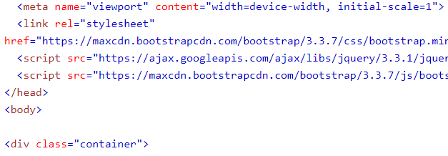

**Figure 3.10: including bootstrap and container class**

**3.3: Requirements to run the application-**

The above languages are client-side languages that will only create a user interface for the user and adding some functioning to it. But for the server side part , we need a language that can easily render all html, css and JavaScript as it will connect server to the database. Web pages will be displayed to the user when they will request for it. For this purpose, we have used localhost as a web server.

**NPM(Node Package Manager)**

It is the essential javascript development tools that helps you to go to market faster and buildpowerful applications using modern source code.

**MongoDB:**

MongoDB is a general purpose, document-based, distributed database built for modern application developers and for the cloud era. No database makes you more productive.

**Nodejs:**

Nodejs is a platform built on Chrome's Javascript runtime for easily building fast and scalable network applications. Nodejs is uses an event-driven, non blocking I/O model that makes it lightweight and efficent, perfect for data-intensive real-time applications that run across distributed devices.

**What nodejs can do?**

* it makes building real-time apps lighting fast,
* it makes coding in Javascript for both the client and server side possible,
* it increases the efficiency of the development process as it fills the gap between frontend and backend developers,
* the ever-growing NPM(Node Package Manager) gives developers multiple tools and modules to use, thus boosting their productivity.
* code executes faster than in any other language,
* Node is perfect for microservices which are a popular solution among enterprise apps.

**Why Nodejs?**

* Nodejs is compatible with almost all servers used today.
* Nodejs supports a wide range of databases
* Nodejs is free. Download it from the official PHP resource: https://nodejs.org
* Nodejs is easy to learn and runs efficiently on the server side.

**4. Database Analyzing, design and implementation**

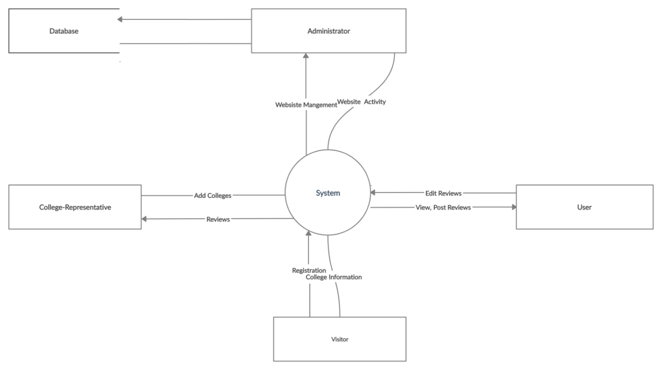

**Figure 4.1 Data Flow Diagram**

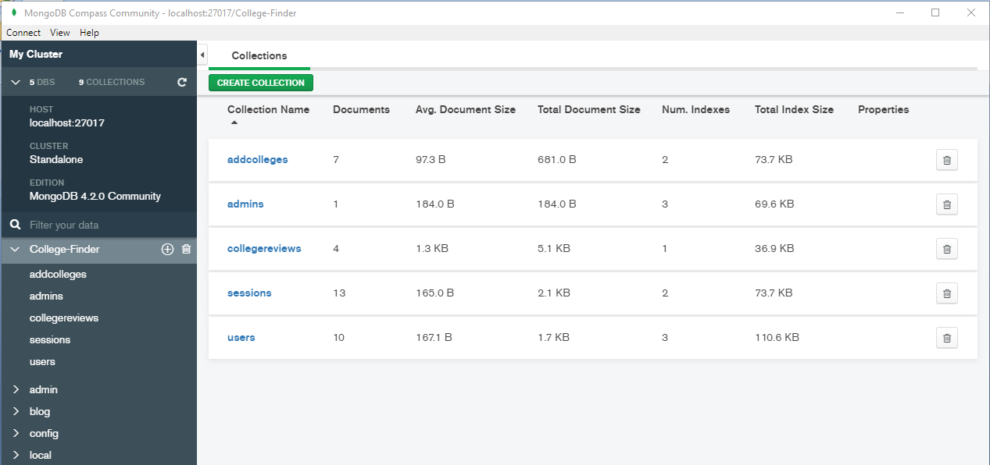

**Fig: 4.2 MongoDB Compass**

**5. PROGRAM’S STRUCTURE ANALYZING AND GUI CONSTRUCTING**

Starting phase of developing the user-interface is shown below.



**Fig 5.1 : Initial Home Page**

We first created layout using bootstrap classes grid system and designed header and footer. Bootstrap css was used to make designing easier.

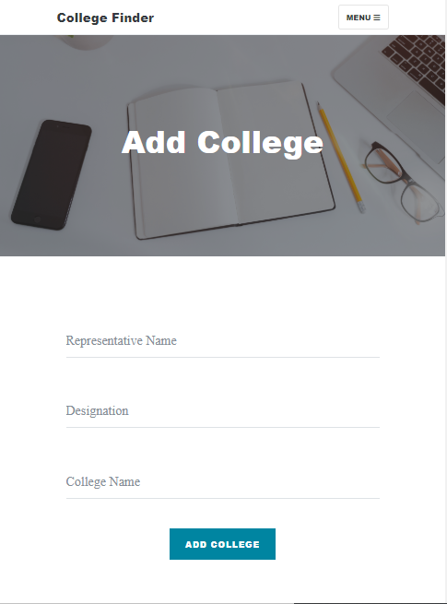

**Fig 5.2 : Add College Page**



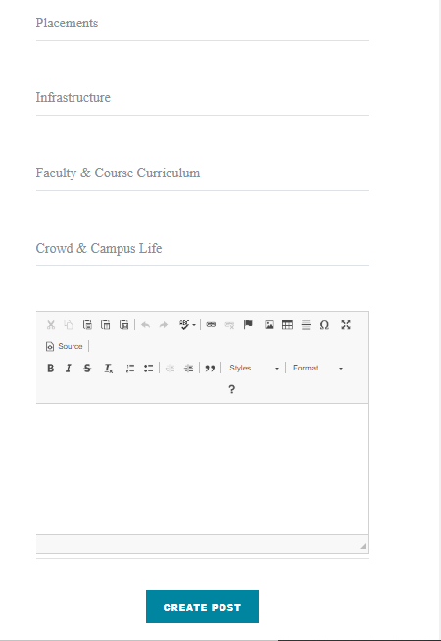

**Fig 5.3 : Reviews Form**

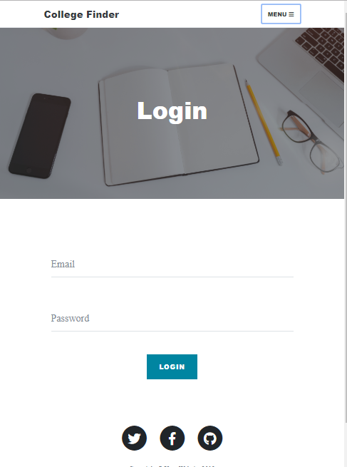

**Fig 5.4: Login Form**

User can post by logging in to this login form. This particular page was designed with using bootstrap.



**Fig 5.5 : Full screen header**

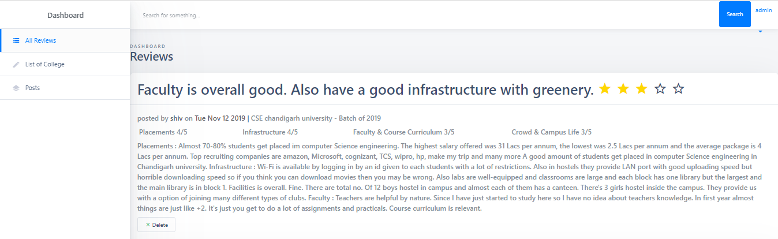

**Fig: 5.6 Admin Panel**

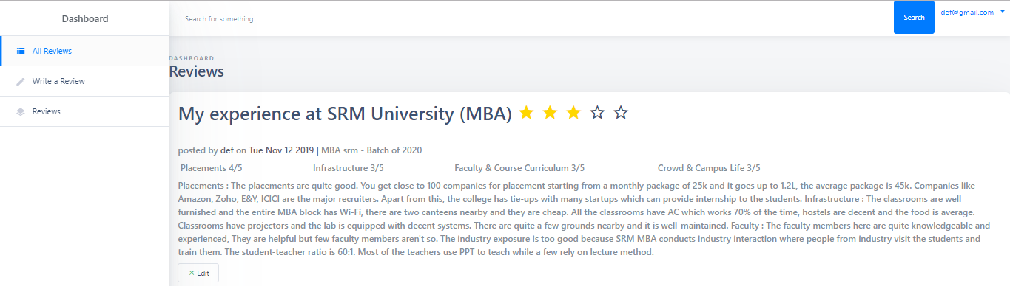

**Fig: 5.7 User Panel**

**6. CODE IMPLEMENTATION AND DATABASE CONNECTION**

**6.1: Code Details & Implementation-**

**\***In this project all the code has been implemented in the editor VS Code.

Although we can write it in any text editor.

*The code has been written in HTML, EJS, CSS, JAVASCRIPT (EXPRESS FRAMEWORK), JQUERY.

*To make our website responsive BOOTSTRAP is used.

*For the database connection MongoDB and Mongoose is used.

**\***All our code is linked to the local server MongoDB with the help of which we can deploy our website on the localhost and run it on any browser of our system.

**6.1.1: MongoDB and Compass–**

* The database for modern applications.

* MongoDB is general purpose, document-based. distributed database built for modern

application developers and for the cloud era.

*No database makes you more productive.

* The GUI for MongoDB. Visually explore your data. Run ad hoc queries in seconds.

* Interact with your data with full CRUD functionality.

* Compass provides view and optimize your query performance.

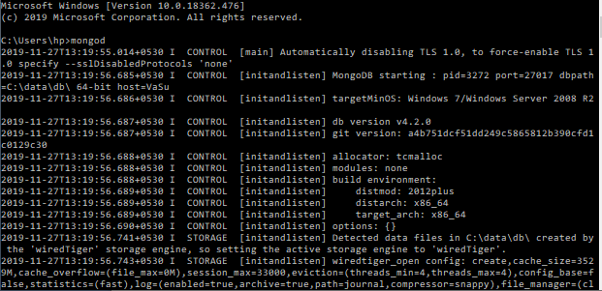

**Figure 6.1: Database Connection**

**\***After starting the actions just open the project and type in cmd 'nodemon server.js' and then in browser type http://localhost/Address of the file you want to open. E.g ([http://localhost:5000](http://localhost/MyCMS/main.php) ).

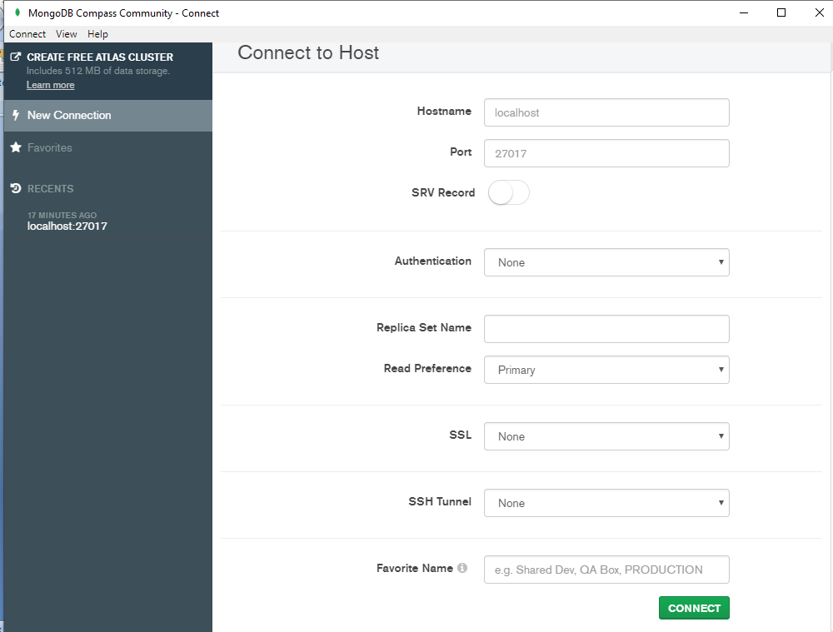

**Figure 6.2: Compass Dashboard**

**6.2: Database Connection -**

**\***To connect with the database we have used the Mongoose connection.

*Code-

mongoose.connect(,{useNewUrlParser:true},function(err){

if(err){ console.log(err);}

else {console.log("Connected to the db");}

});

*After making the connection we handle the database using PHP through which all our data get stored in MongoDB database in different collections and documents.

*To fetch the data from the database too, javascript is used.

*To go to the database, go to cmd type 'mongod' database server started and then click on MongoDB compass.



**Figure 6.3: Project Database**

**7. LIMITATIONS**

As every application our project also has some limitations i.e the things we tried but were unable to implement-

*We are unable to make a proper user profile system. We aimed at making a system that will keep all the track record of the user and also user can edit his/her details, upload profile picture.

*We also wanted to make a much better commenting system through which the people can like and dislike the reviews as well.

*We would also like to send notification to the user whenever someone posts a comment on his post.

*There is also a scope of improvement in the add colleges section. College Representative

can also give the details about college.

*There is need of report button i.e flag for the inappropriate reviews.

**8. CONCLUSION**

I discovered that any project is not that much easy as it looks. If one wants to make a good project than one has to give his best to make that project work.

Although it was a wonderful learning experience for me while working on this project. This project took me through the various phases of project development and gave me real insight into the world of development. The joy of working and the thrill involved while tackling the various problems and challenges gave me a feel of developers industry.

It was due to this project that I get an idea of how actually projects are designed.

I enjoyed each and every bit of work I had put into this project. Our project provides the exact solution to our problem statement.

By signing in, the user can post his/her reviews about the colleges/universities that will displayed on the dashboard once the admin verifies it . Then from there it will be visible to all the users. The user who posted the review can also edit the review. Admin monitored each reviews posted by the user. The project is further extendable.

As we know there is no project which is bug free and has no limitations and so is ours. Some of the major limitations of our project are mentioned below:

* User cannot like or dislike the reviews.
* Need more parameter for rating the colleges/universities.
* No notification system.
* Admin may be biased.
* So a flag i.e a report button is required for the reviews.

**9. FUTURE SCOPE**

* We know it is not feasible to the registered all colleges/universities of India. So the very

first step is to start with the colleges/universities in north area and then covered other regions

of India.

*Thus there is a vast scope in future for our application.

*First we need to deploy it on the server and then we can expand its database to more and more colleges by contacting them.

*We can make suitable changes and can add new features according to the market response and requirements as there is always a scope for improvement.

*And once it gets successful we can think of earning through it as big projects always start from a crap.

*Also we can launch for the google play store, and ios to make it more accessible to the people.

**10. Bibliography/References**

* https://www.google.com
* https://www.w3schools.com/html
* htpps://www.w3schools.com/css
* https://www.w3schools.com/bootstrap
* https://www.npmjs.com
* https://www.mongodb.com
* https://nodejs.org